MEAM 5290 FEA

Stress and Frequency Analysis of Folded Spring System in MEMS Gyroscope

Vicky Chen, Andy Xiao, Vaibhav Wanere

**Introduction**

The field of microelectromechanical systems (MEMS) has revolutionized sensor technology, enabling the development of highly sensitive and compact devices for numerous applications. Among these, vibratory gyroscopes represent a cornerstone in precision navigation and motion sensing, operating on the principle of Coriolis force to detect angular velocities. In this context, our study delves into the mechanics of a MEMS gyroscope, focusing specifically on the stress and frequency characteristics of a critical component: the folded spring system.

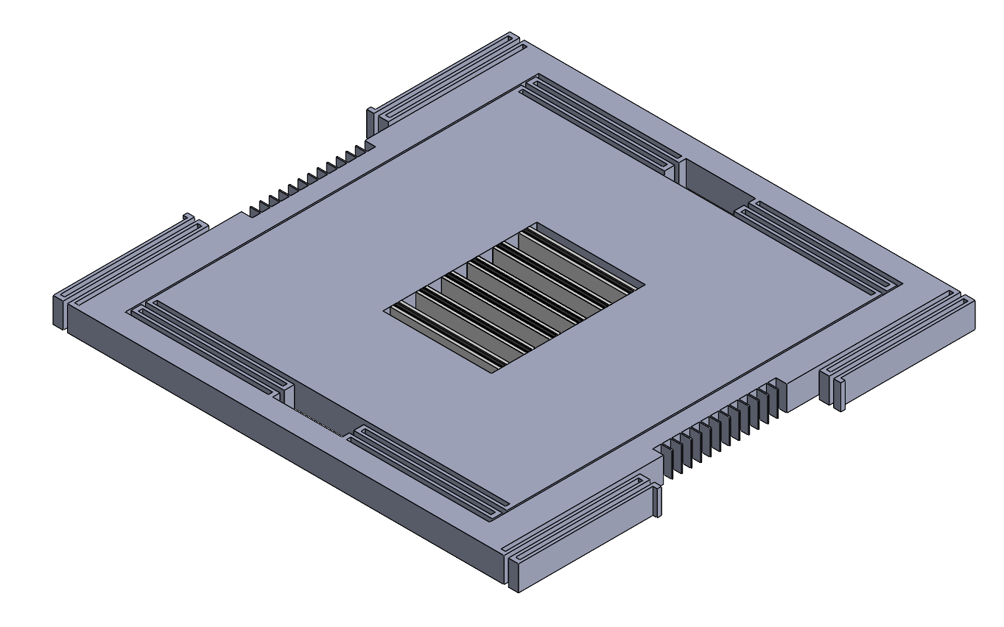 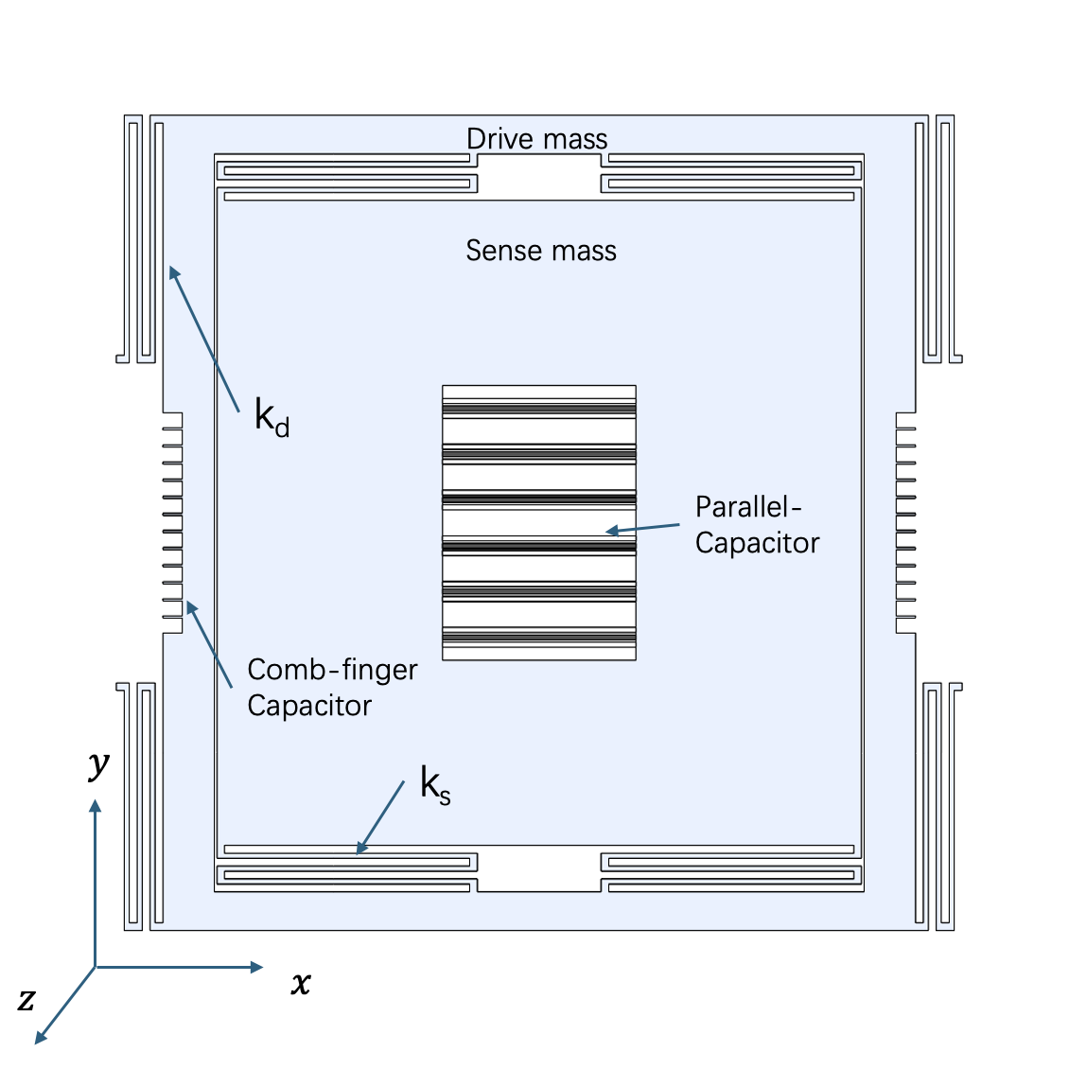

Figure 1: Gyroscope Design

This study presents a detailed analysis of the folded spring structure that connects the driving and sensing masses within the MEMS gyroscope. By leveraging finite element analysis (FEA) techniques implemented through COMSOL Multiphysics®, we aim to evaluate the mechanical behavior and vibrational dynamics of this spring. Through examinations of stress distribution, displacement profiles, and eigenfrequencies, our investigation seeks to understand the underlying principles governing the performance and reliability of the gyroscope system.

The overall geometry's boundary conditions were defined prior to conducting the analysis. The linear elastic solid mechanics module will then be used to do stress analysis, while the eigenfrequency module will be used for natural frequency analysis. An additional 1-D plot group will be used to demonstrate the y-displacement of the bottom most beam element. Simulation results will be compared with analytical results, and the discussion will focus on the accuracy and validity of the finite element model, as well as the convergence of different mesh sizes.

**Mathematical Modeling**

**Second Order Spring Mass Damper System:**

Following figure shows the schematic representation of a gyroscope with forces acting and axis of rotation:

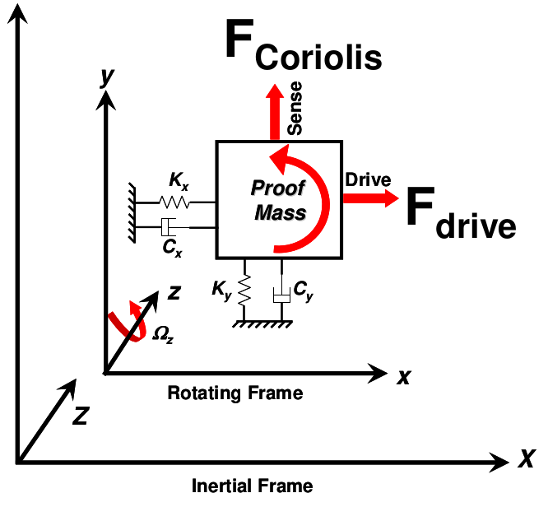

Figure 2: Gyroscope Design

The drive mass is subjected to a sinusoidal force called F_drive and the sense mass experiences Coriolis force when the system is under rotation.

Mathematically, the system can be modeled as a second order spring mass damper system.

The maximum displacement of the sense mass is determined as given below:

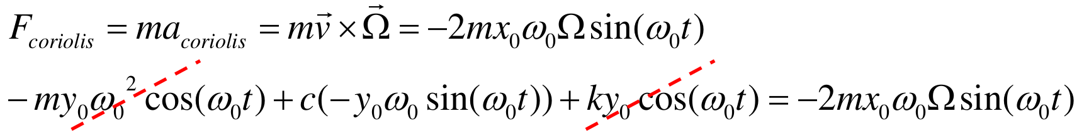

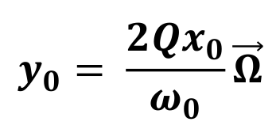

**Linear Elastic Solid Mechanics Model**

The stress and deformation of a structure under static loads The following equilibrium equation is used, which is the Cauchy Momentum Equation at static condition:

0 = ∇·S + Fv

Where Fv is the external force volume density, and S is the stress tensor. The other equations define the stress tensor S as the sum of inelastic (Sinel) and elastic (Sel) components, which are further decomposed into various strain components. Since the gyroscope works in the linear elastic region of the stress-strain curve, we can safely ignore the inelastic strains. Therefore, solid mechanics of MEMS gyroscope spring can be modeled using the equations of linear elasticity and structural dynamics. The displacement field u is governed by the equation of motion, which relates the inertial forces (ρü, where ρ is the density) to the internal stresses S and external forces Fv.

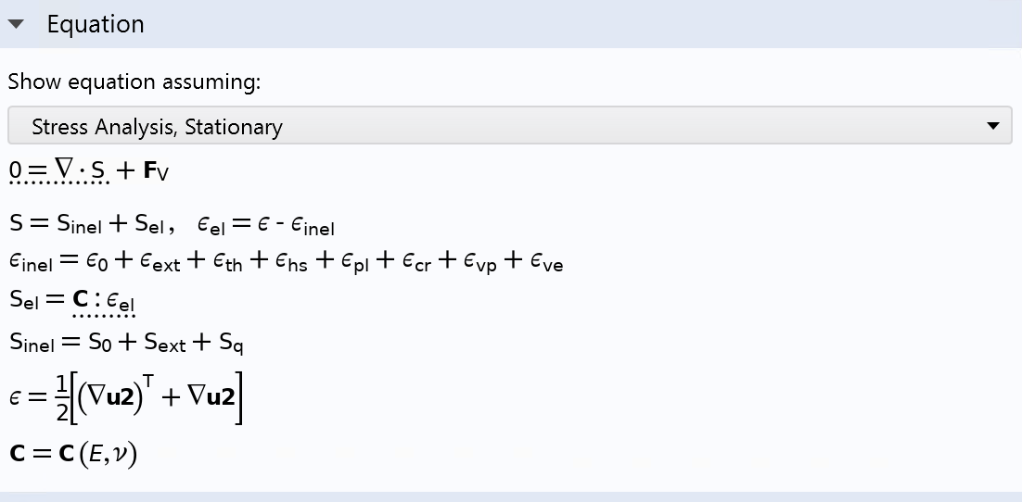

The internal stress S are related to the strains ε through Hooke's law for linear elastic materials. The strains ε are derived from the displacement field u using appropriate strain-displacement relations.

**Eigenfrequency Analysis:**

To calculate the natural frequencies and mode shapes of a structure, an eigenfrequency analysis is needed and the following equations are used:

-ρω²u = ∇·S and -iω = λ

Where ω is the eigenfrequency (natural frequencies) and u corresponding mode shapes (eigenvectors).

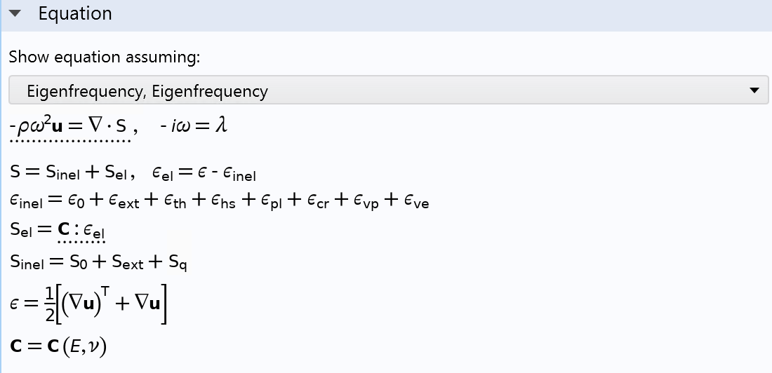

The Boundary Condition at the end of the beam consists of a dead mass at the end of the spring system and is equal to one fourth of the mass of the sense element in the gyroscope.

**COMSOL Multiphysics® Implementation**

For a single folded beam structure, there are two distinct boundary conditions defining both stress and eigenfrequency modules. The folded beam geometry is constructed in COMSOL Multiphysics® by combining elements with the *Union* option, so that the overall structure is merged into one single domain. For the folded beam structure shown in Fig. 3, a fixed condition is applied to the interface between the drive mass and the beam structure itself, since the drive mass is relatively stationary with respect to the shuttle/sensing mass. A fixed condition specifies that, in local coordinates, the displacement [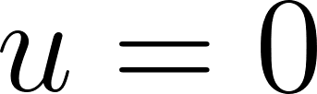](https://www.codecogs.com/eqnedit.php?latex=u%3D0#0), as seen in Fig. 4. The second roller condition specifies that, in local coordinates, the selected surface is only able to move in the plane with which it is parallel.

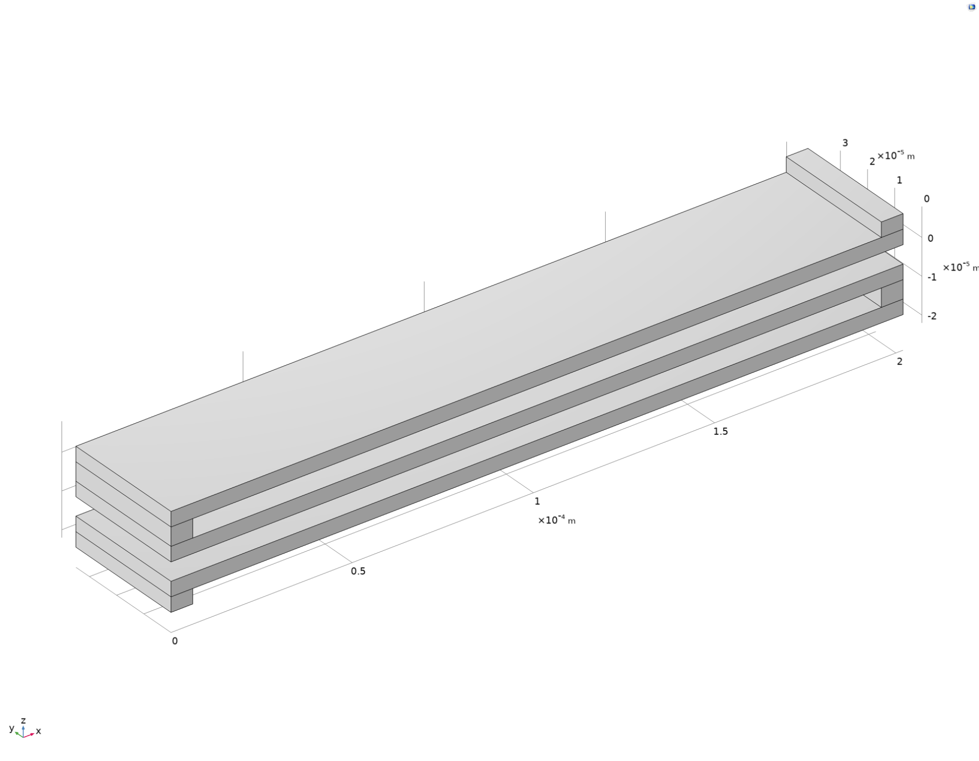

Figure 3: Isometric View of the Folded Beam Structure Model

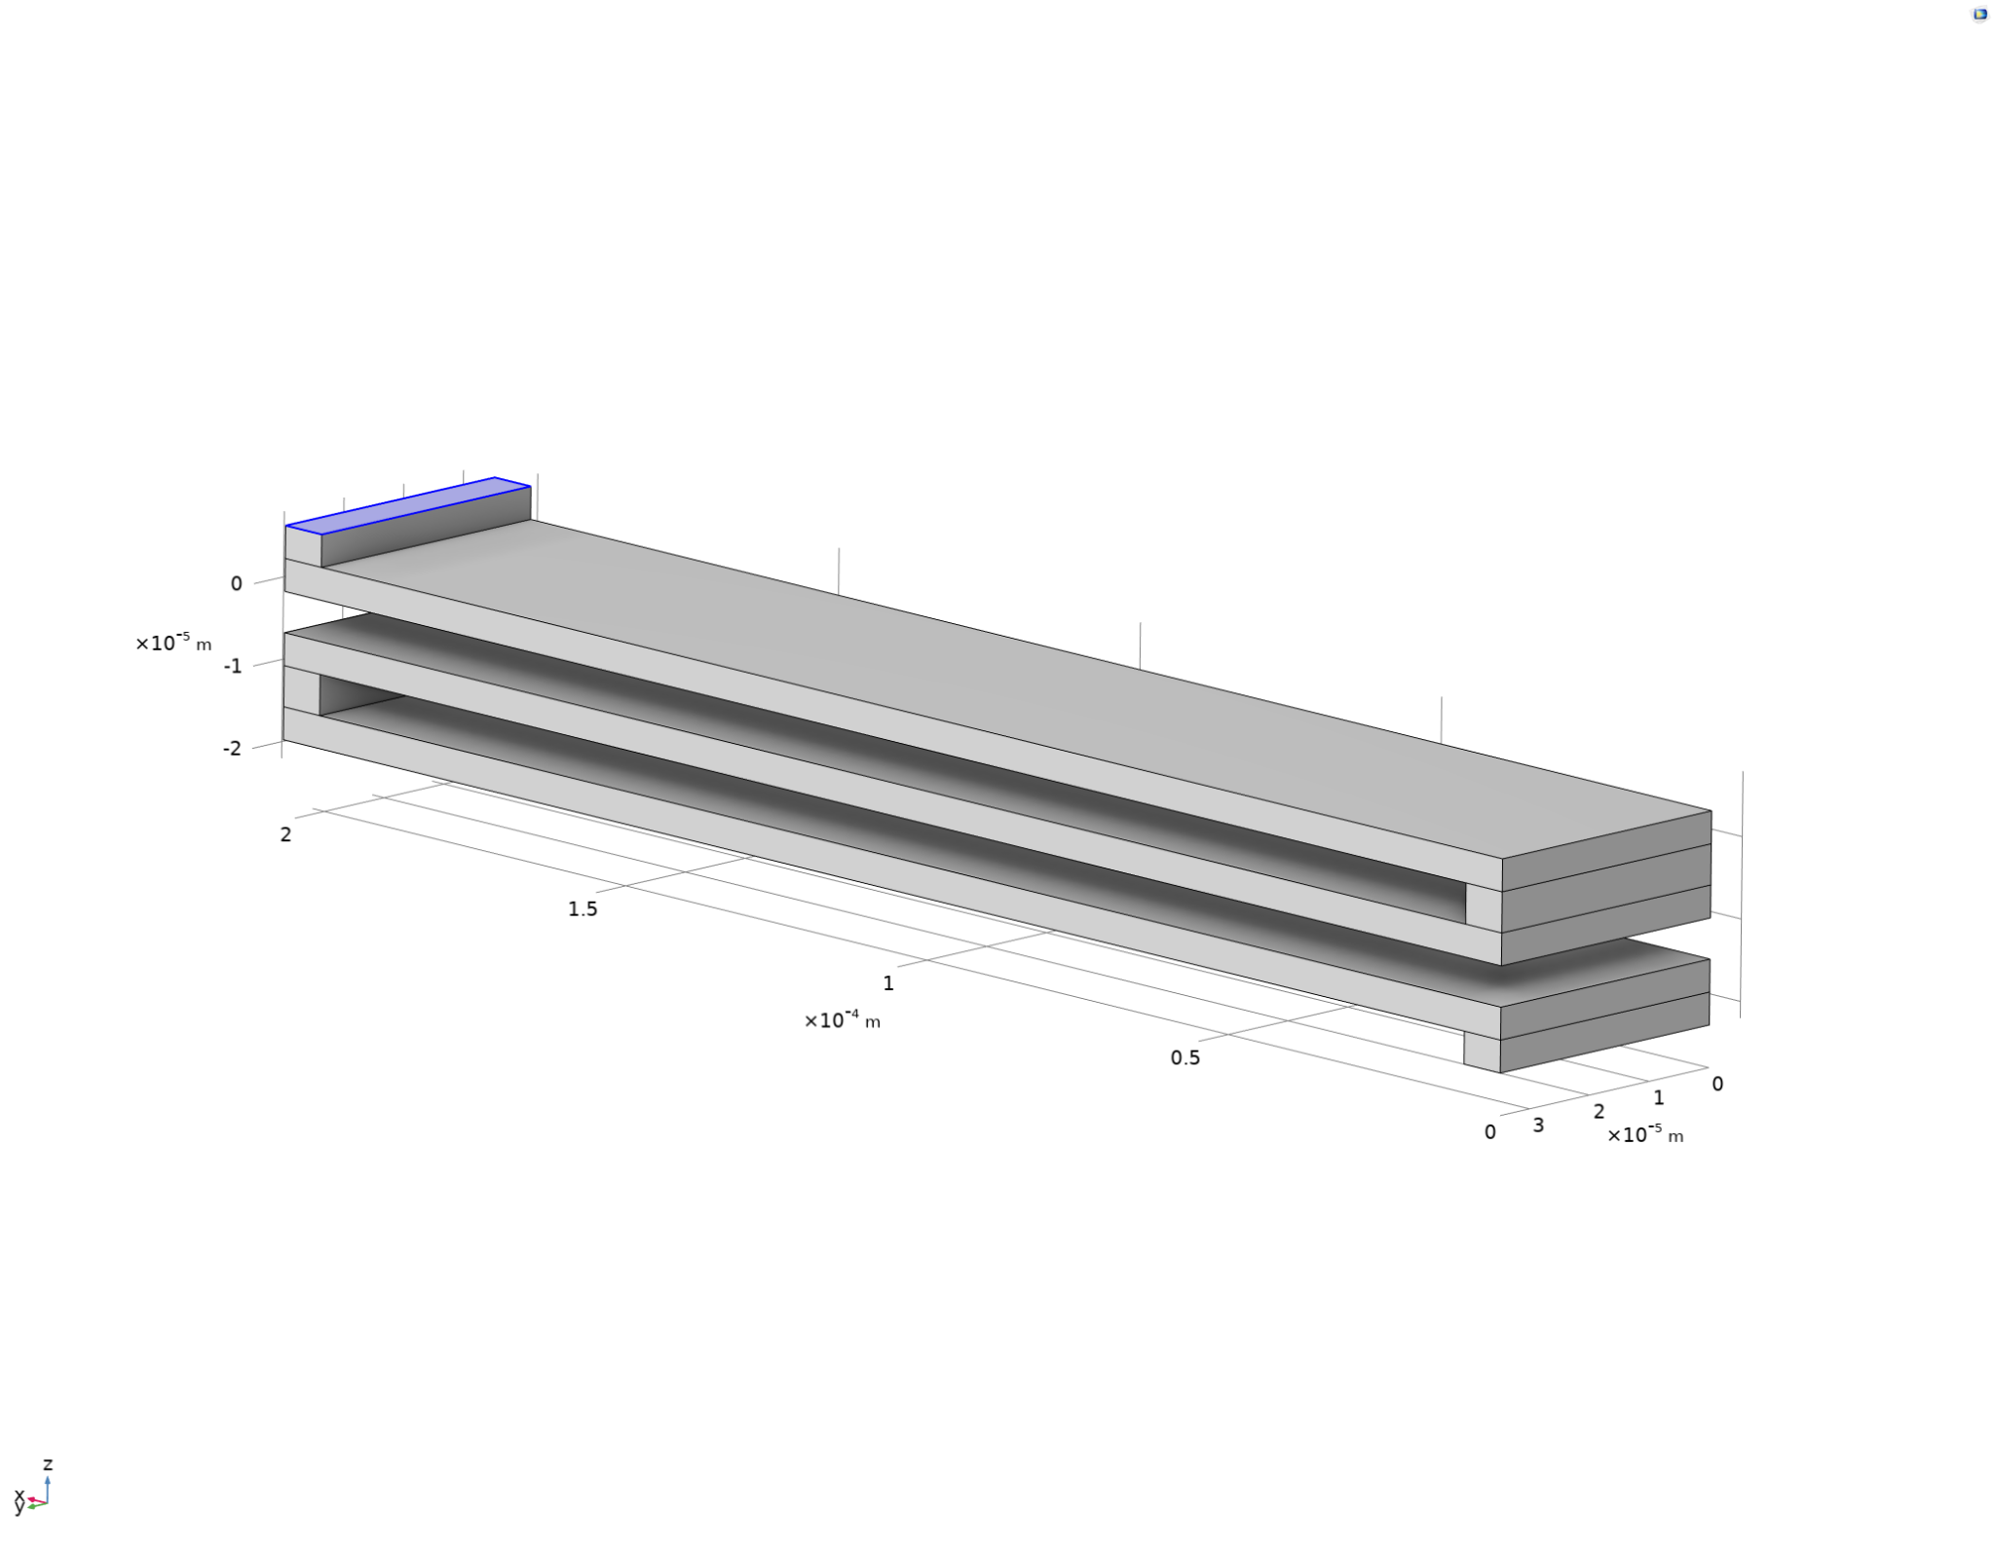

Figure 4: Fixed Condition Imposed on the Highlighted Surface

In a clamped-guided beam structure, one end will be fixed, and the other end is constrained to only be able to move vertically, thus the roller condition on the surface. In COMSOL Multiphysics® representation, a dot product between the surface and the unit vector normal to the surface is set to zero: [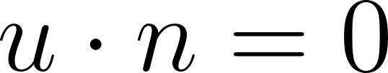](https://www.codecogs.com/eqnedit.php?latex=u%5Ccdot%20n%20%3D%200#0), as shown in Fig. 5.

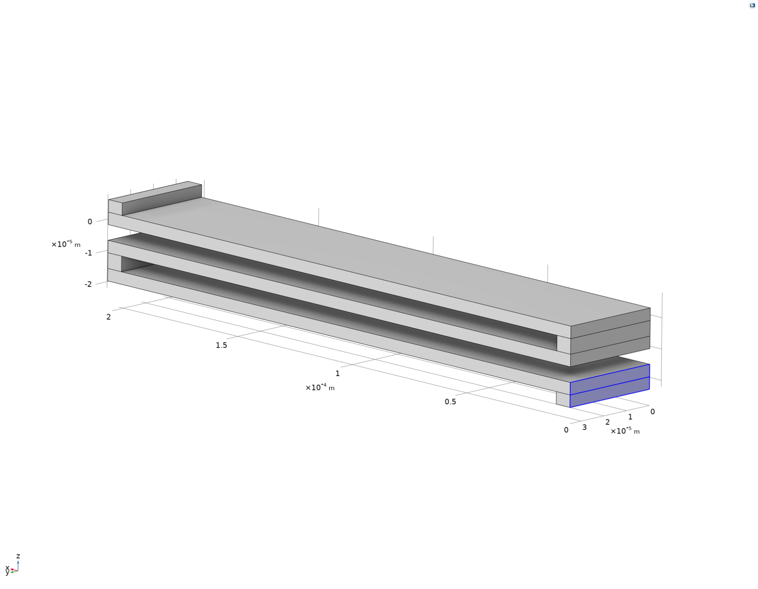

Figure 5: Roller Condition Imposed on the Highlighted Surface

For the interface between the shuttle/sense mass and the folded beam structure, shown in Fig. 6, a force condition - its magnitude derived from [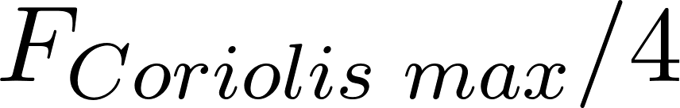](https://www.codecogs.com/eqnedit.php?latex=F_%7BCoriolis%5Ctext%7B%20%7Dmax%7D%2F4#0) since the force is equally distributed to four of the same fold beams - is imposed to this surface, which then induces stress to the overall spring structure. However, since the eigenfrequency of the folded beam structure is independent of any external force but only dependent on the geometry and boundary conditions, the previous force condition is replaced by a mass condition on the same surface, and the magnitude of the mass is given by [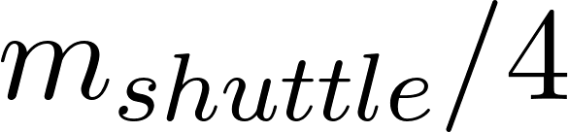](https://www.codecogs.com/eqnedit.php?latex=m_%7Bshuttle%7D%2F4#0) for a similar reason.

Our analytical results assumed the connecting elements between the horizontal beams are rigid, as shown in Fig. 7, since the spring constant is much higher in the z-axis than in x-axis. Therefore, a slight discrepancy might be attributed to the finite element analysis from the theoretical results. The rest of the beam structure is encompassed by the default free condition, while the overall structure is encompassed by the default initial conditions: [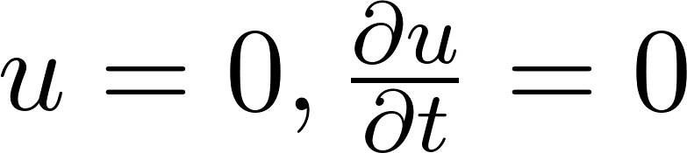](https://www.codecogs.com/eqnedit.php?latex=%20u%3D0%2C%20%5Cfrac%7B%5Cpartial%20u%7D%7B%5Cpartial%20t%7D%3D0#0), as shown in Fig. 8.

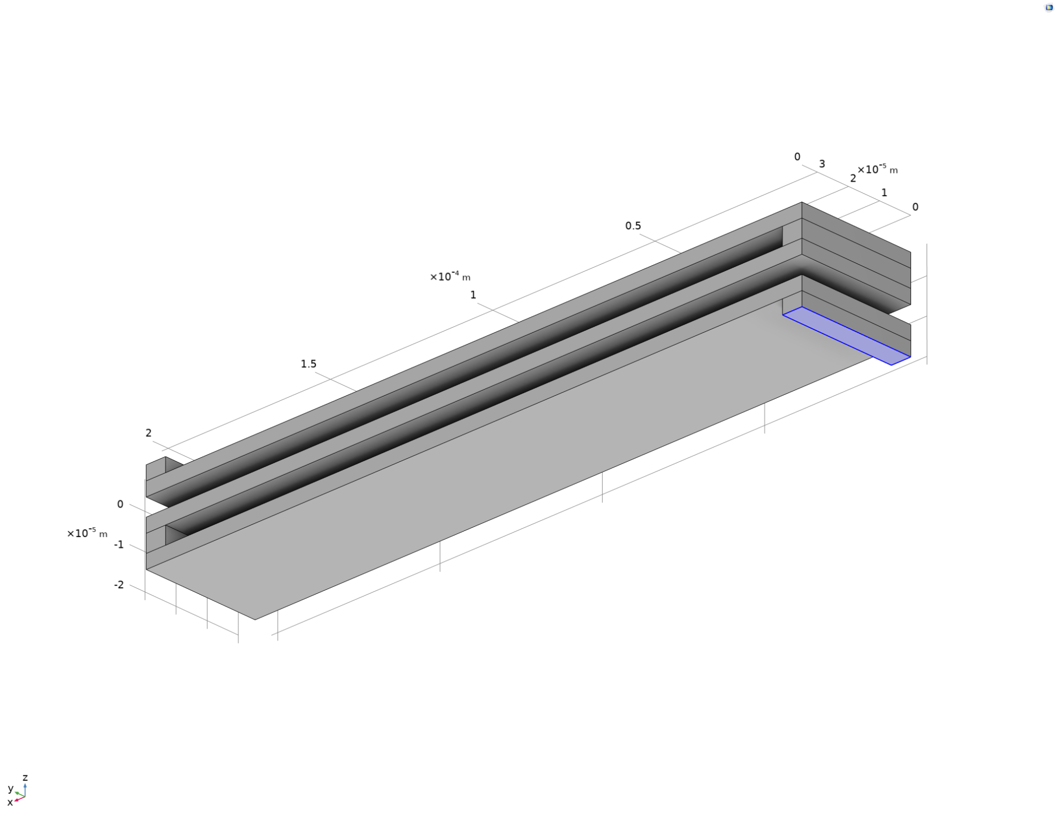

Figure 6: Force/ Mass Condition Imposed on the Highlighted Surface

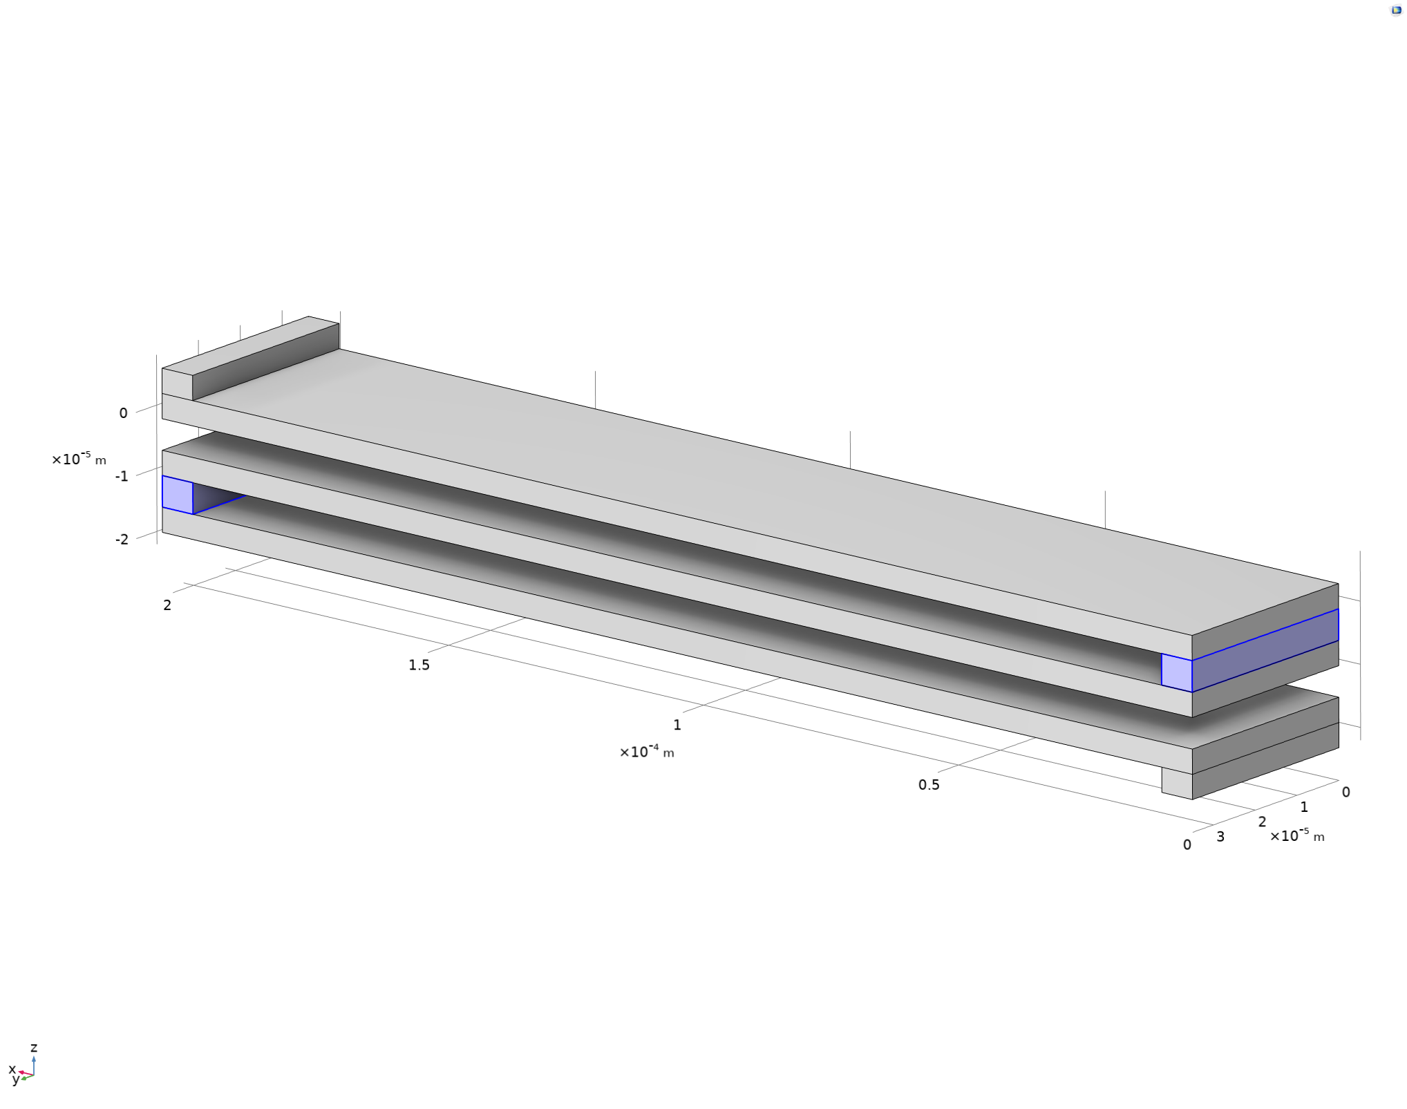

Figure 7: Connecting Elements Are Assumed Rigid in Theoretical Calculations

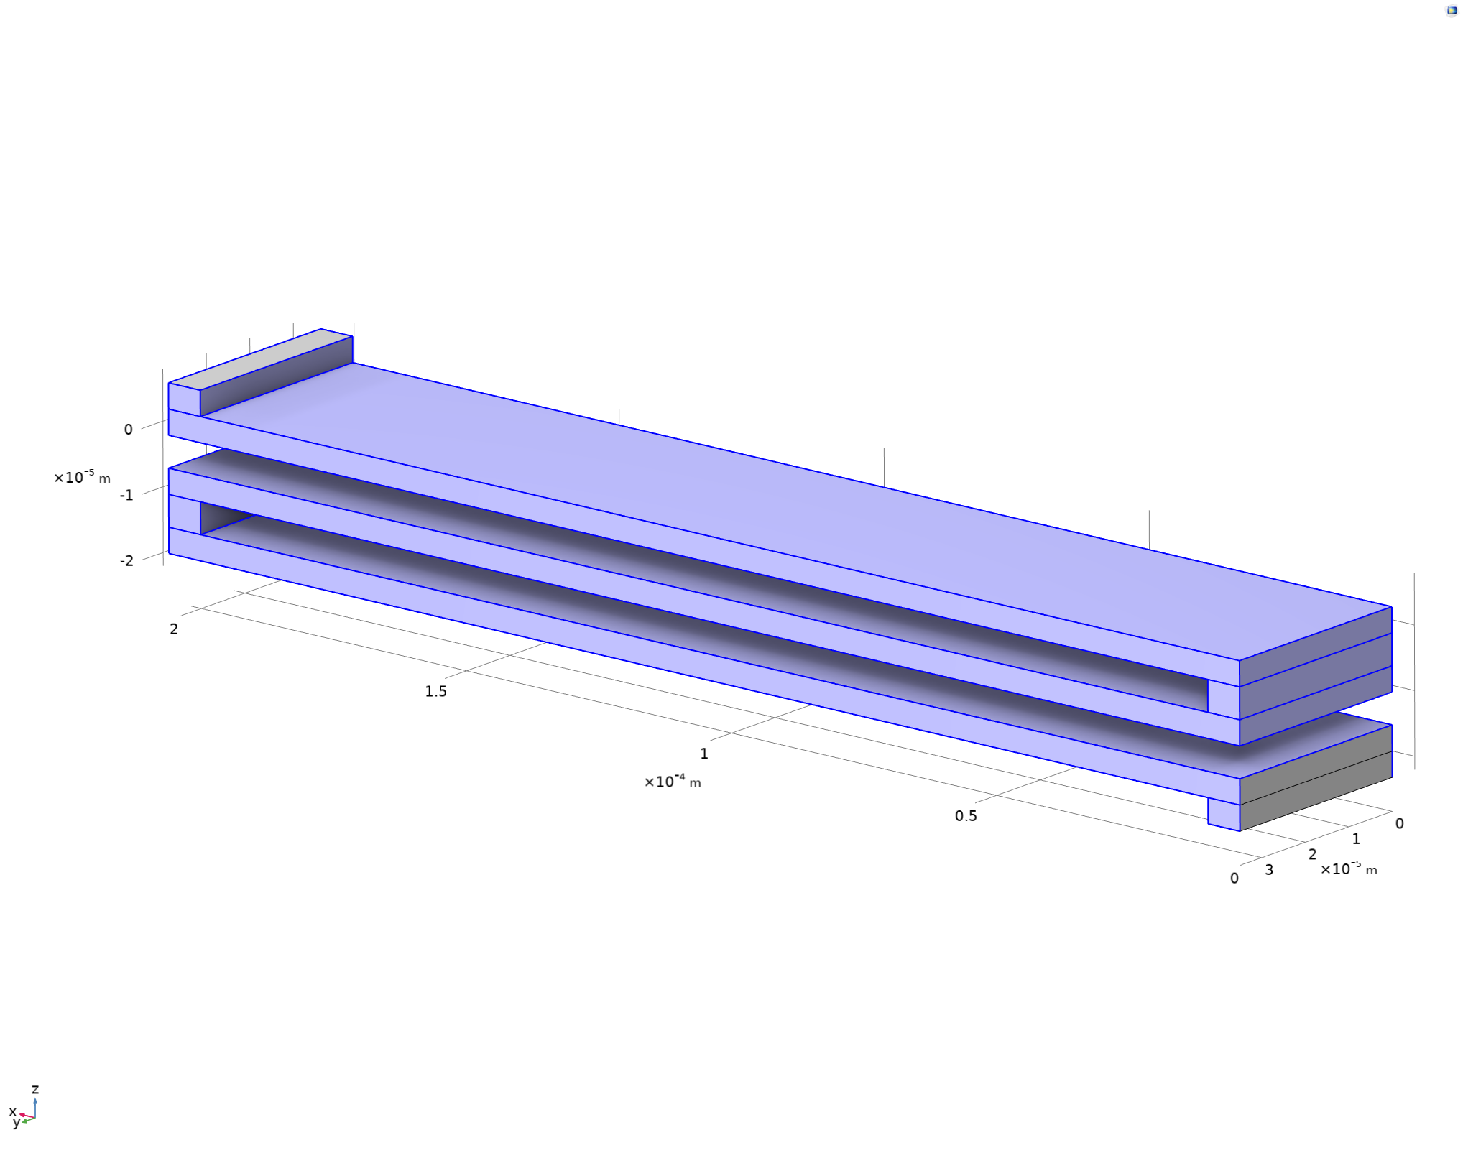

Figure 8: Surface Elements Subjected to Initial Conditions

**Validation/ Mesh convergence**

Mesh convergence is an essential aspect of finite element analysis (FEA) to ensure the accuracy and reliability of the simulation results. In the case of the MEMS gyroscope spring analysis, a mesh size of 3E-6 m (3 μm) was selected. The complete mesh consisted of 42,161 domain elements, 13,756 boundary elements, and 1,144 edge elements, resulting in 211,308 degrees of freedom (DOFs) to be solved.

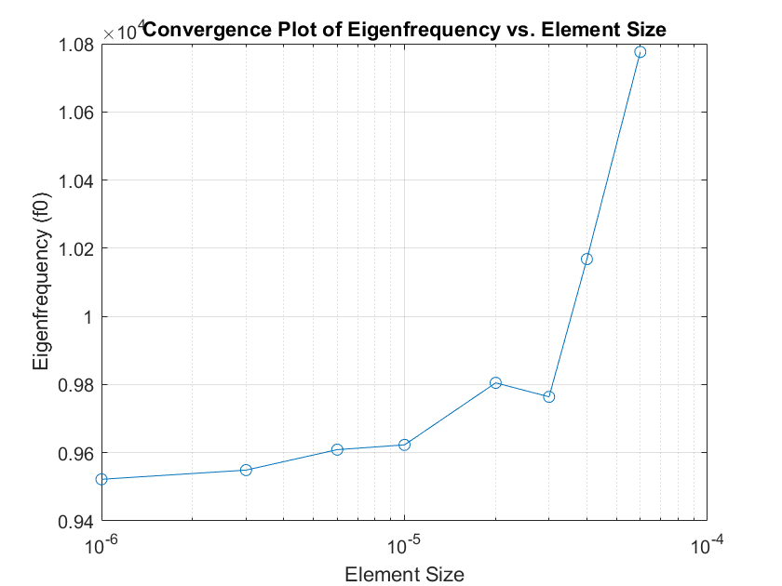

Figure 9: Mesh Convergence for Eigenfrequency Analysis

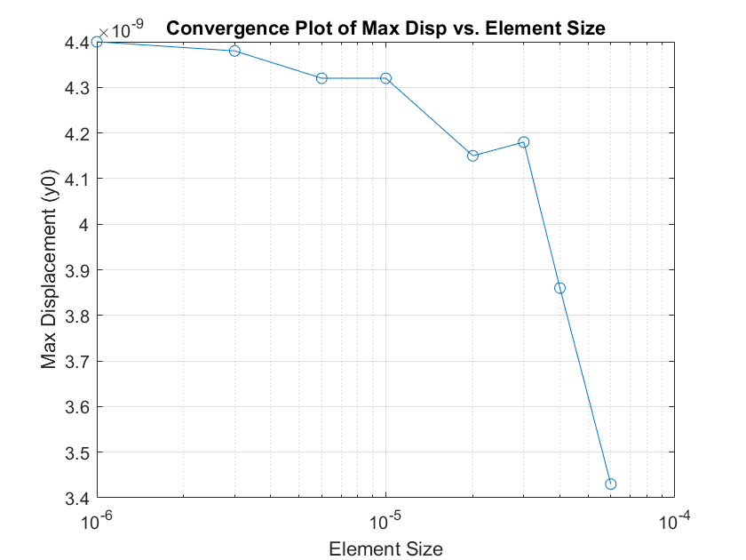

Figure 10: Mesh Convergence for Displacement Analysis

The convergence plots for eigenfrequency and maximum displacement provide valuable insights into the mesh convergence behavior. The eigenfrequency plot shows that as the element size decreases, the eigenfrequency converges to a stable value, indicating that the mesh resolution is sufficient to capture the dynamic behavior accurately. Similarly, the maximum displacement plot exhibits a converging trend as the element size decreases, suggesting that the mesh is adequately resolving the deformation field.

With a solution time of 6 seconds for stress analysis and 7 seconds for eigenfrequency analysis, the computational effort is reasonable for the given mesh density. The calculated maximum displacement and eigenfrequency are, 4.38E-9m and 9549 Hz, respectively. The mesh convergence study confirms that the selected mesh size of 3E-6 m provides reliable and accurate results for the MEMS gyroscope spring analysis, ensuring that the simulated behavior closely represents the actual physical phenomenon.

Moreover, the maximum stress in the structure is 91000 Pa and the Tensile strength of Polysilicon is 1.25 GPa. The tensile strength is used instead of yield strength as Polysilicon is a brittle material.Moreover, the maximum stress in the structure is 91000 Pa and the Tensile strength of Polysilicon is 1.25 GPa [1]. The tensile strength is used instead of yield strength as Polysilicon is a brittle material. The maximum stress is well below the tensile strength which validates the linear assumption.

**Results/ Discussion**

After all boundary conditions have been imposed, stress distribution is simulated and the result is shown in Fig. 11. It is evident that most stresses occur at the two ends of the beam element, as shown by the prism color representation. The absolute value of stress is higher where the colors tend toward red, and stress is neutral where colors tend toward purple and white. It is worth noting that there is zero stress along the neutral axis along the xy-plane, as seen in the white color representation in the middle of the beam thickness.

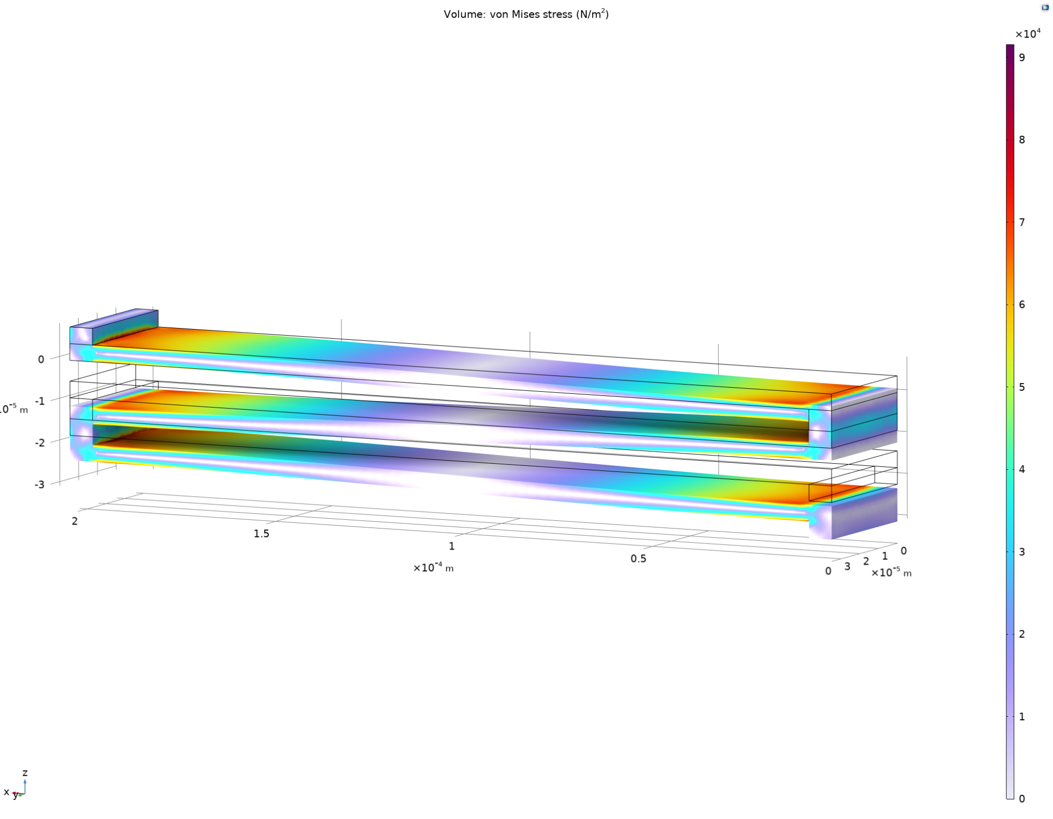

Figure 11: Von Mises Stress Distribution Under Load

Fig. 13(a) demonstrates the y-displacement along the bottom most beam element, highlighted in Fig. 12. According to the finite element model, the maximum y-displacement of the overall beam structure is on the order of [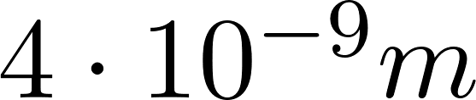](https://www.codecogs.com/eqnedit.php?latex=4%5Ccdot%2010%5E%7B-9%7D%20m#0), which is consistent with our theoretical value of 4.67E-9 m. The displacement in Fig. 13 captures shown the total displacement of the structure and

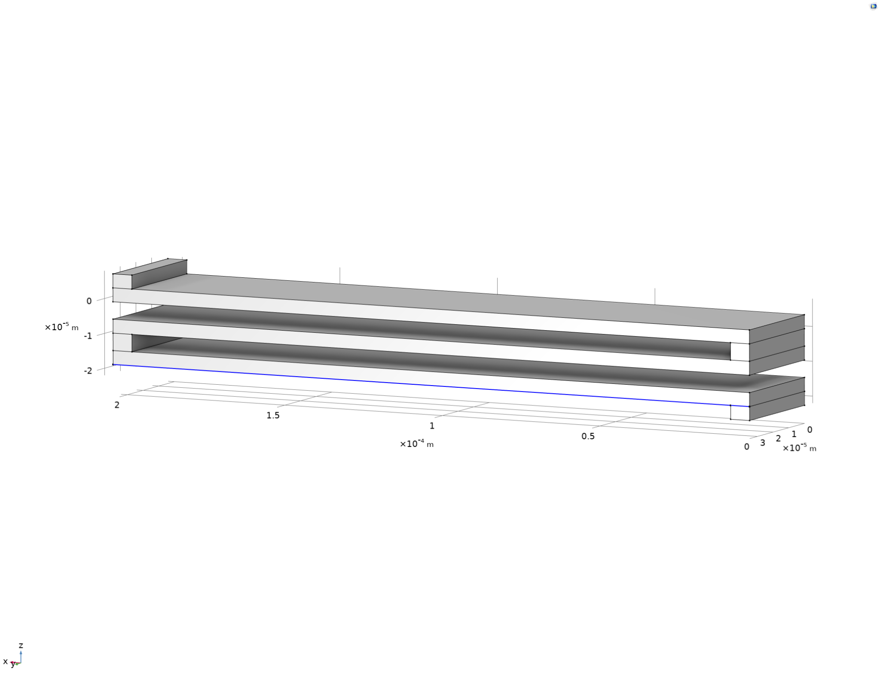

Figure 12: Maximum Y-displacement Occur at the Bottom Right Corner of the Structure

Additionally, the maximum displacement curve of the beam element, driven at the natural frequency, as seen in Fig. 13 is also consistent with that of a clamped-guided beam. The analytical relation between force and displacement in y is given by the equation: [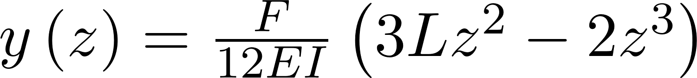](https://www.codecogs.com/eqnedit.php?latex=y%5Cleft(z%5Cright)%3D%5Cfrac%7BF%7D%7B12EI%7D%5Cleft(3Lz%5E2-2z%5E3%5Cright)#0), where L is the length of the beam element, z is the arc length variable along the beam, and F is the force applied.

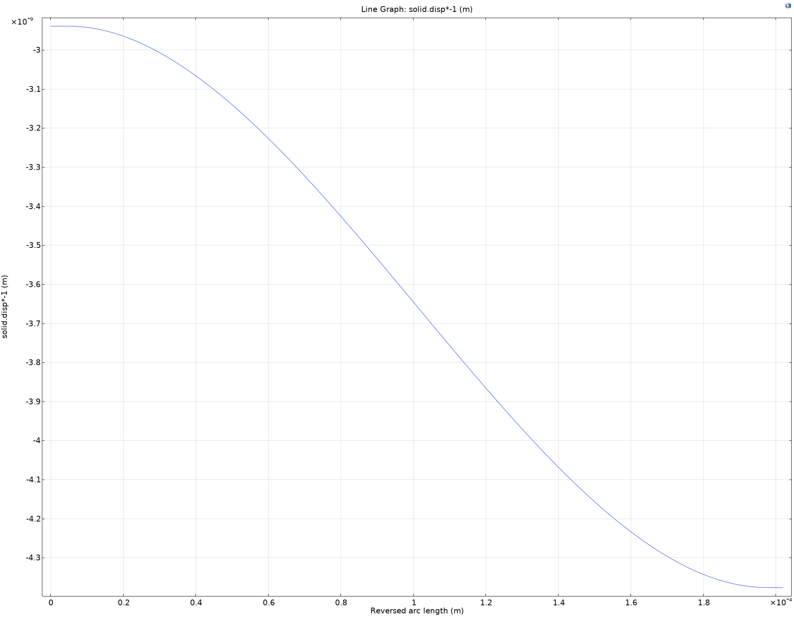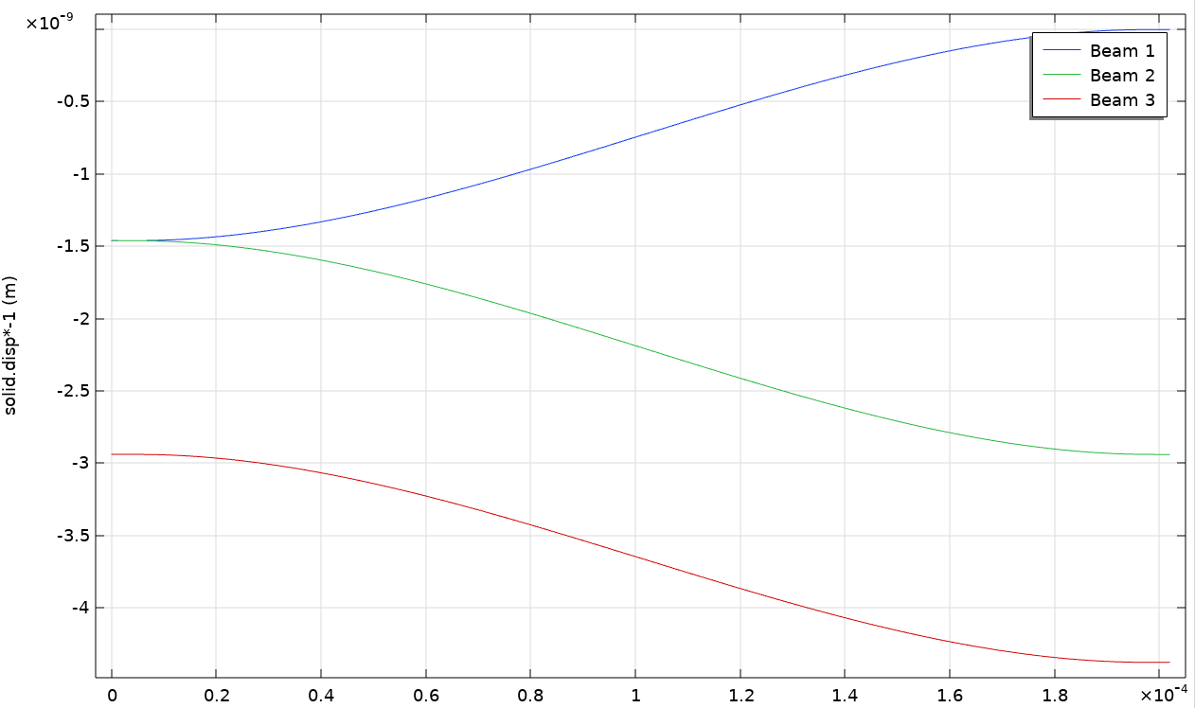

Figure 13: Y-displacement vs. Beam Arc Length (a) Highlighted in Figure 12 (b) Total Displacement

For the eigenfrequency analysis, the force condition is disabled and replaced with the appropriate mass condition, as previously mentioned, and the simulation result of the first fundamental frequency is shown in Fig. 14. The simulation result indicates that the fundamental vibration mode is in the z-axis, and the fundamental frequency f0 is approximately 9.6 kHz. Our gyroscope design prescribes f0 to be 10kHz. The discrepancy can be partly attributed to the maximum mesh size, [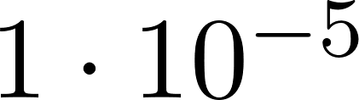](https://www.codecogs.com/eqnedit.php?latex=%201%5Ccdot%2010%5E%7B-5%7D%20#0), used in the simulation. Furthermore, our theoretical calculations made some simplifying assumptions, such as the rigid connector elements between each beam.

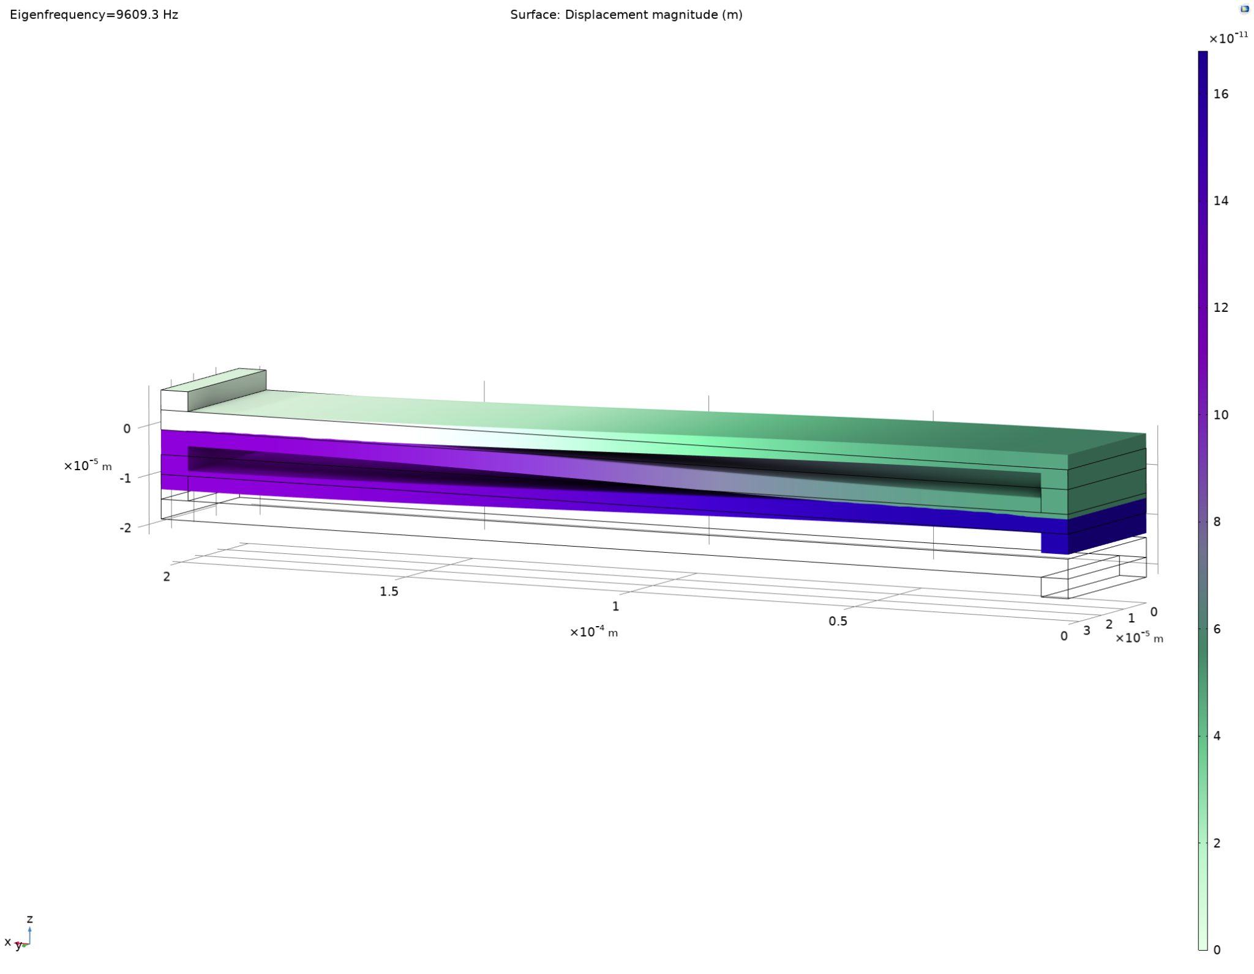

Figure 14: The First Fundamental Frequency of The Folded Beam Structure

Using the calculated maximum displacement and eigenfrequency are, 4.38E-9m and 9549 Hz, respectively. These COMSOL Multiphysics® numerical solutions were then compared with analytical solutions of the entire system. It was found that the error between numerical and analytical results for maximum displacement and natural frequency are 6.2% and 4.5%, respectively. One reason why these errors occur is that when the analytical solution is calculated the spring constant of connecting blocks is very high compared to the beam thus it was deemed as rigid in our calculations. Moreover, for finite element analysis (FEA) techniques, numerical approximations and discretization errors are always present. The COMSOL Multiphysics® simulations are given greater confidence by these comparatively low error percentages, which show strong agreement between the numerical simulations and analytical models.

**Conclusion**

In this study, a comprehensive analysis of the folded spring structure within a MEMS gyroscope was conducted, employing finite element analysis (FEA) techniques implemented through COMSOL Multiphysics®. The investigation focused on evaluating the mechanical behavior and vibrational dynamics of the spring system, crucial for understanding the performance and reliability of the gyroscope. Through simulations, the stress distribution, displacement profiles, and eigenfrequencies of the folded spring structure were determined. The mesh convergence study confirmed that the chosen mesh size provided reliable and accurate results. The calculated maximum displacement and eigenfrequency closely matched theoretical values, validating the accuracy of the numerical approach. Moreover, the stress analysis revealed that the maximum stress within the structure remained well below the tensile strength of the material. Additionally, the comparison between numerical and analytical results indicated a strong agreement.

**References**

[1] Sharpe, W.N., Turner, K.T. & Edwards, R.L. Tensile testing of polysilicon. *Experimental Mechanics* **39**, 162–170 (1999). <https://doi.org/10.1007/BF02323548>

[2] COMSOL Multiphysics® v. 6.2. www.COMSOL.com. COMSOL AB, Stockholm, Sweden.